# TASK1

Ask AI to write a function to calculate compound interest, starting with only the  
function name. Then add a docstring, then input-output example

# TASK 2

Write a function to calculate average, median, and  
mode of a list of numbers

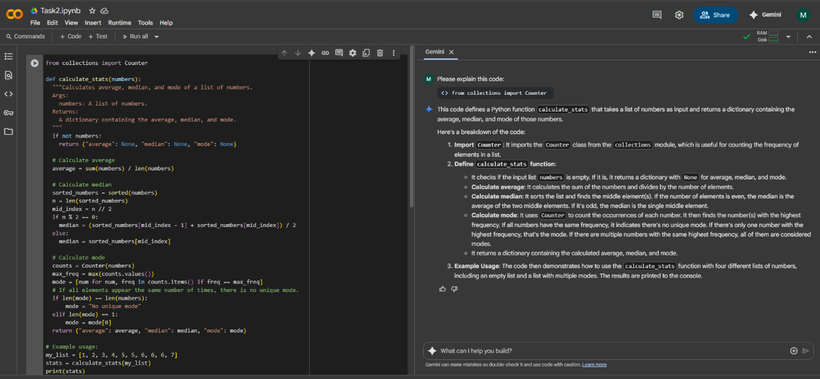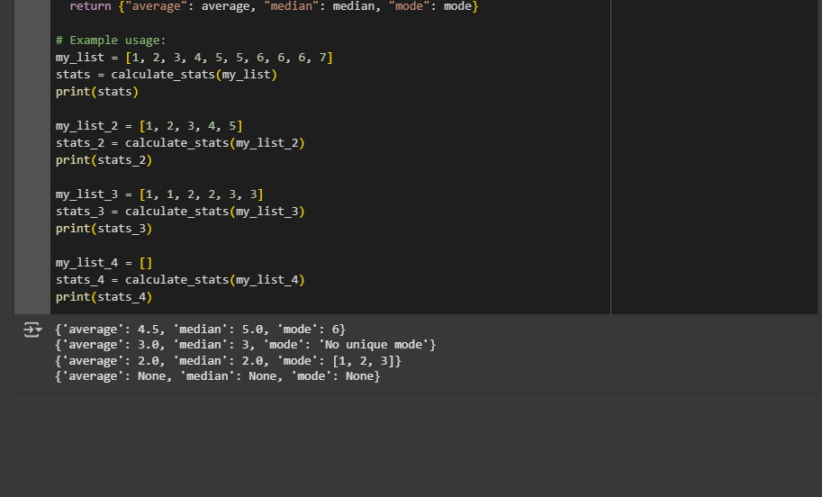

# TASK3

Provide multiple examples of input-output to the AI for convert_to_binary(num)  
function. Observe how AI uses few-shot prompting to generalize.

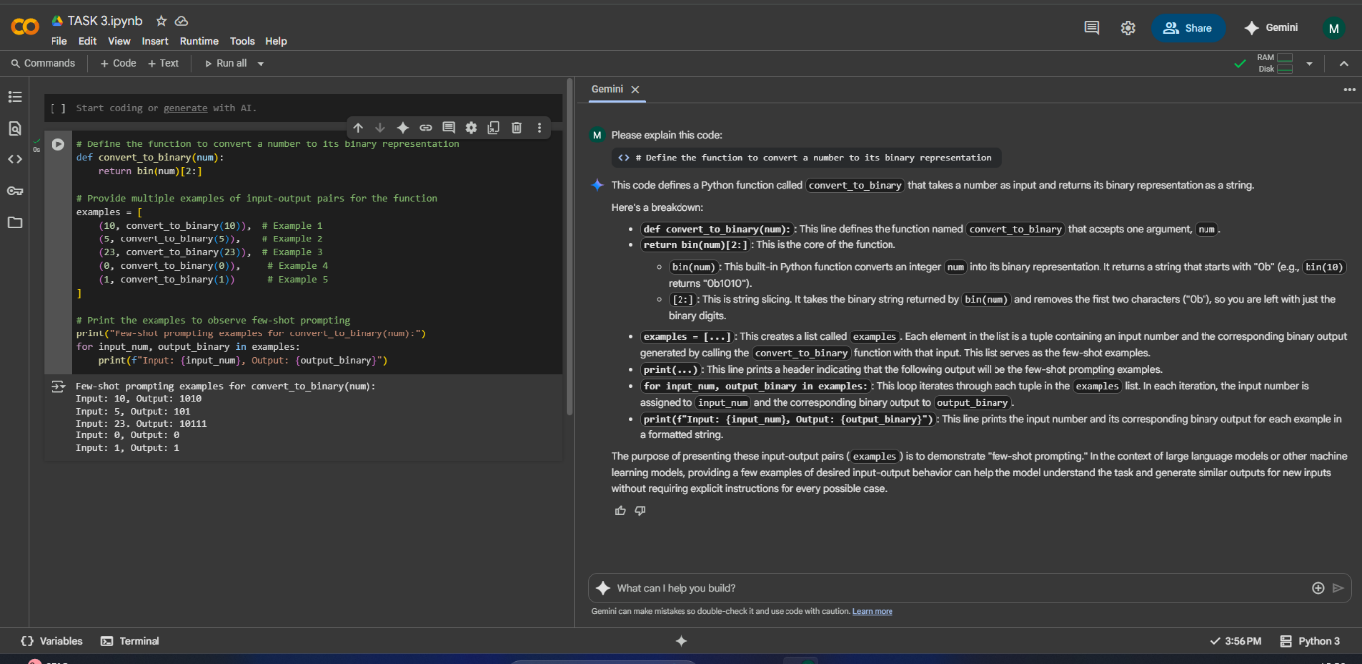

# Task4

Create an user interface for an hotel to generate bill based on customer requirements

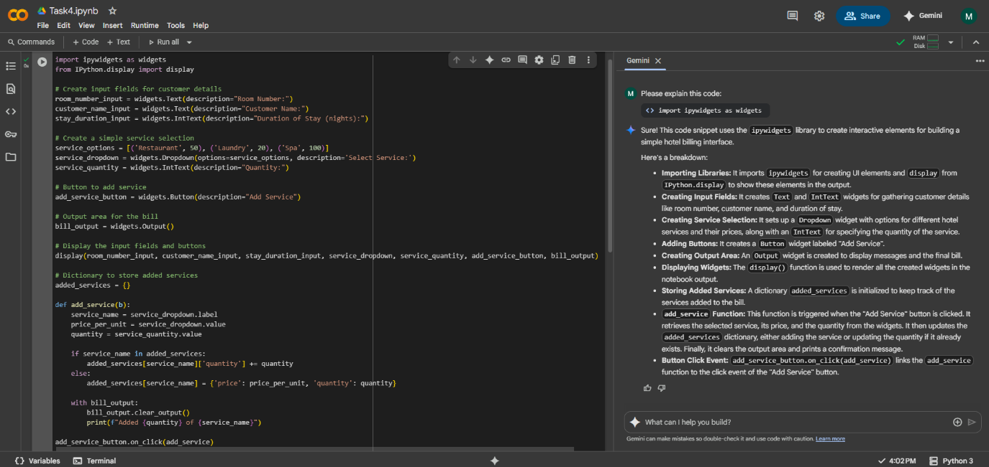

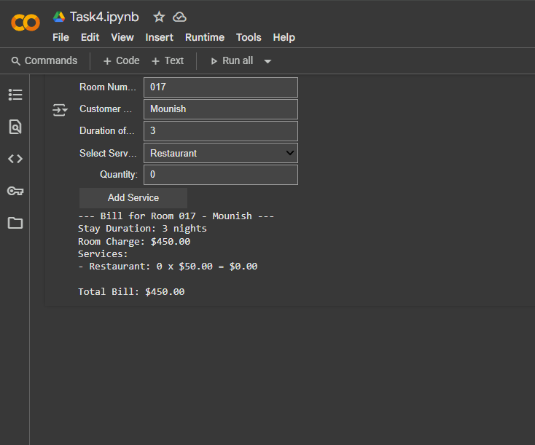

# Task5

Analyzing Prompt Specificity: Improving Temperature Conversion Function with  
Clear Instructions

